**SQL Server Integration Services (SSIS) Tasks**

**Load Data from SQL Server source to flat file Destination**

1. Create a data flow task in control flow name it as “SQL Server to Flatfile”
2. Double click it and open data flow
3. Choose an OLE DB source and a flatfile destination and put in design area and link output using blu line of OLE DB source to flatfile
4. Double click OLE Db source and create a new connection and select Adventureworks Database hosted on SQL Server. In Data access mode use table and then choose DimSales Territory table.

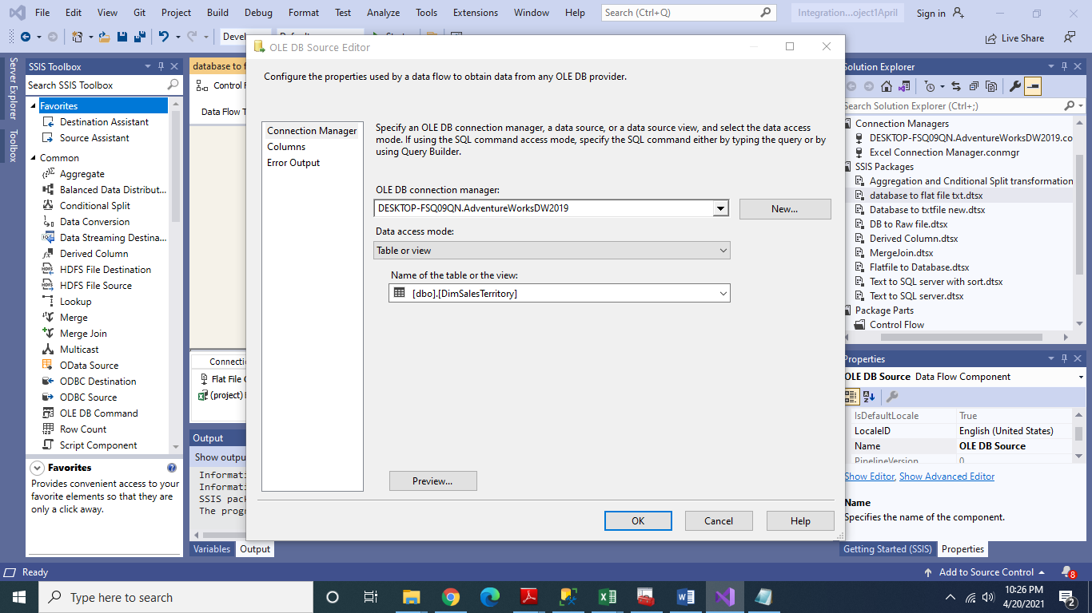

1. Choose Columns tab and link External column and output column. Here you can select column of your choice. Here I have chosen 4 columns as shown

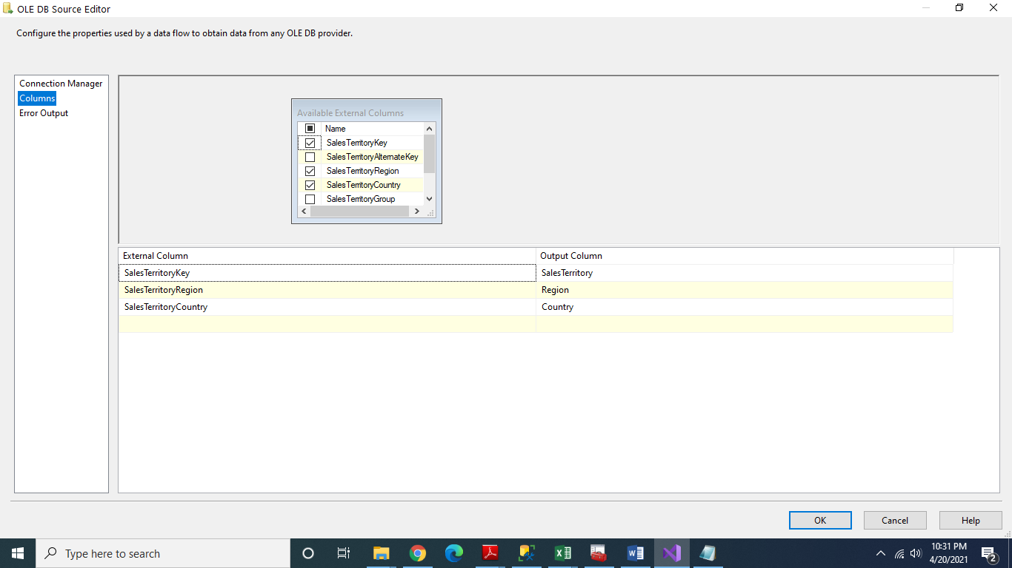

1. Now double click Flat file destination and in connection manager create a new connection manager and create a file. Here I have created a file with name territory data. You can select any of file type. Here we choose Delimited.
2. On Mappings tab you will set link input columns and destination columns.

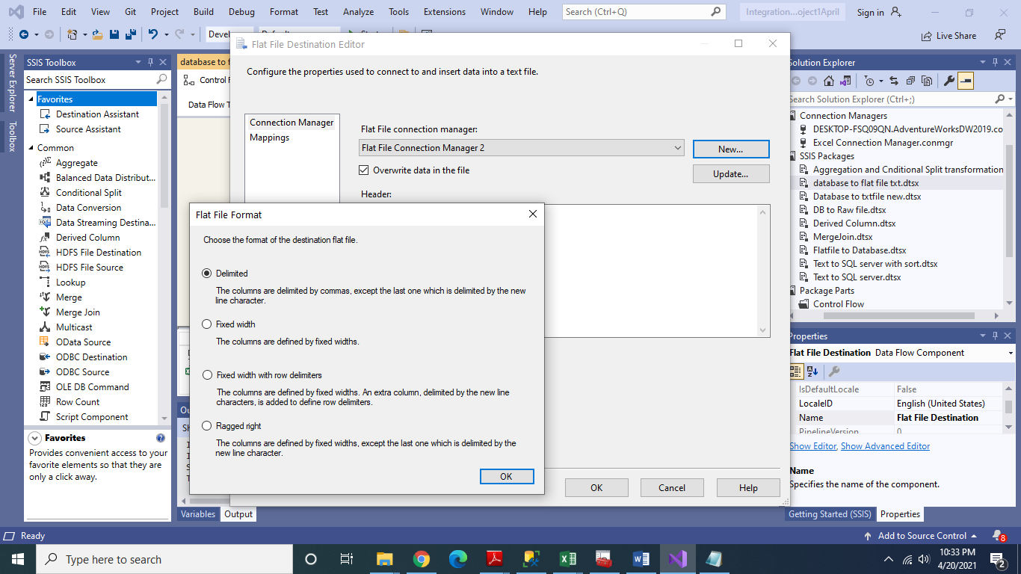

1. Enable Data viewer by right clicking on link between OLE DB source and Flat file destination.

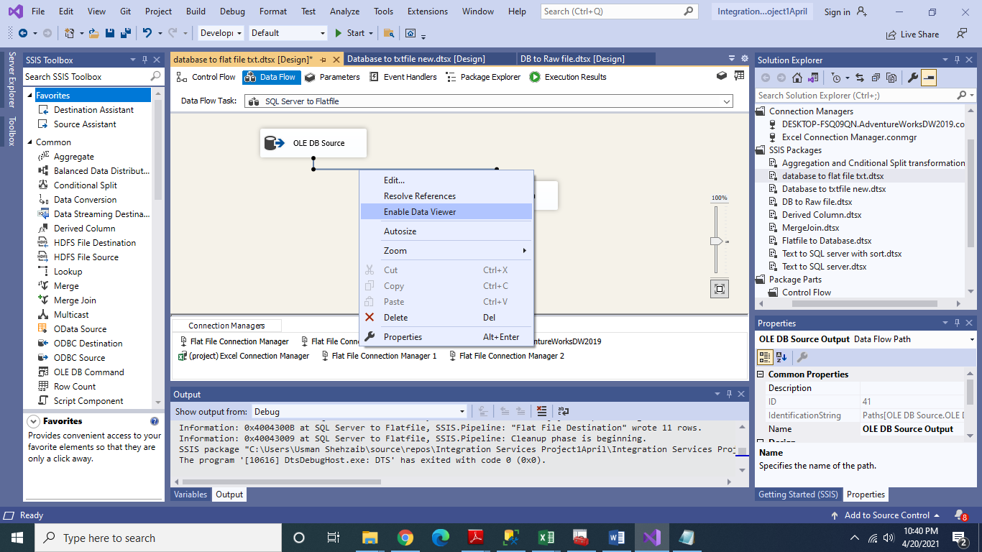

1. Execute the package by clicking start and if it succeeds you will get following data in your destination file.

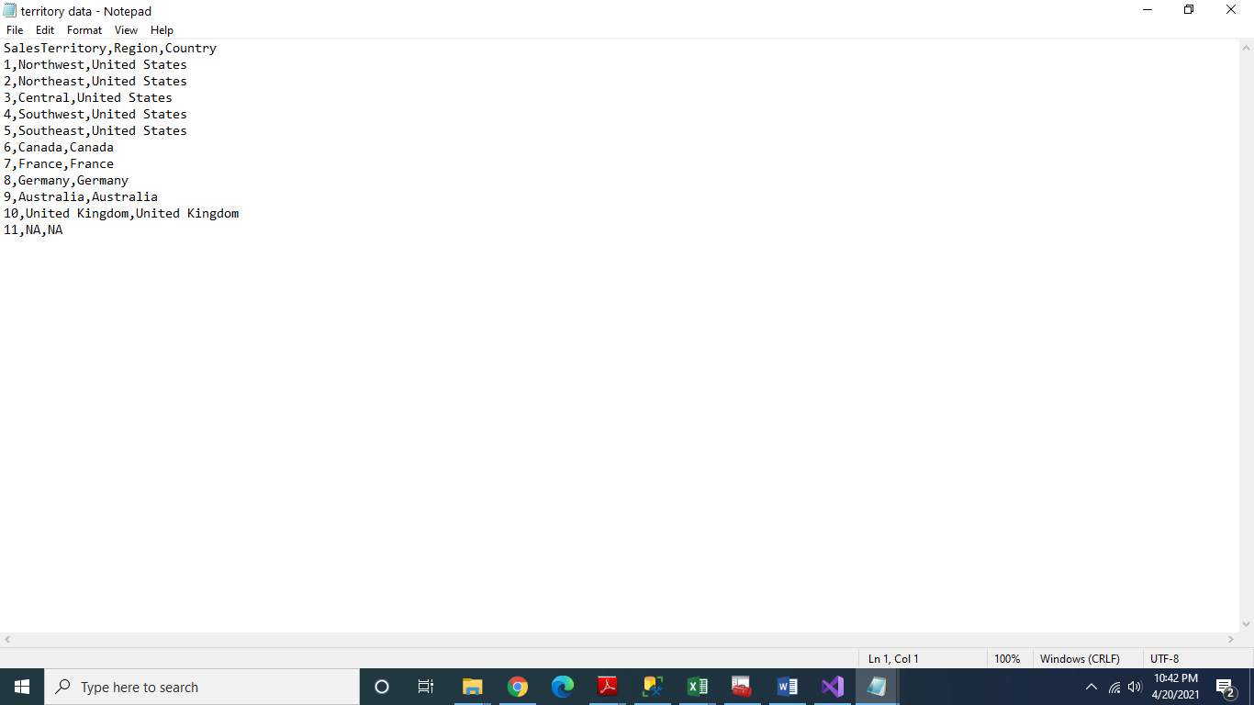

**Load Data flat file source to SQL Server Destination**

Conceptually we will perform these steps in reverse for this task

1. Now choose a flat file source and OLE DB as destination
2. Double click flat file source and link with your data file of Google apps data(This file is available in Google class). Here again you can select columns of your choice. In this case we are having five columns.

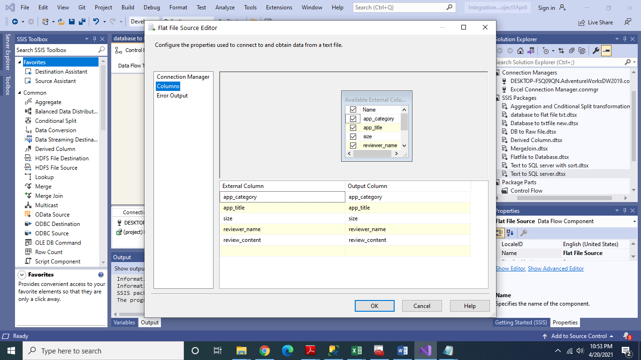

1. Link Flatfile output with OLE DB input using Blue line and enable Data Viewer.
2. Now go to SSMS and create a new database with name “flatfile” and in this database create a table with name “appdata” as shown in figure. Also create five columns with proper data types which will be used for data loading from apps data file.

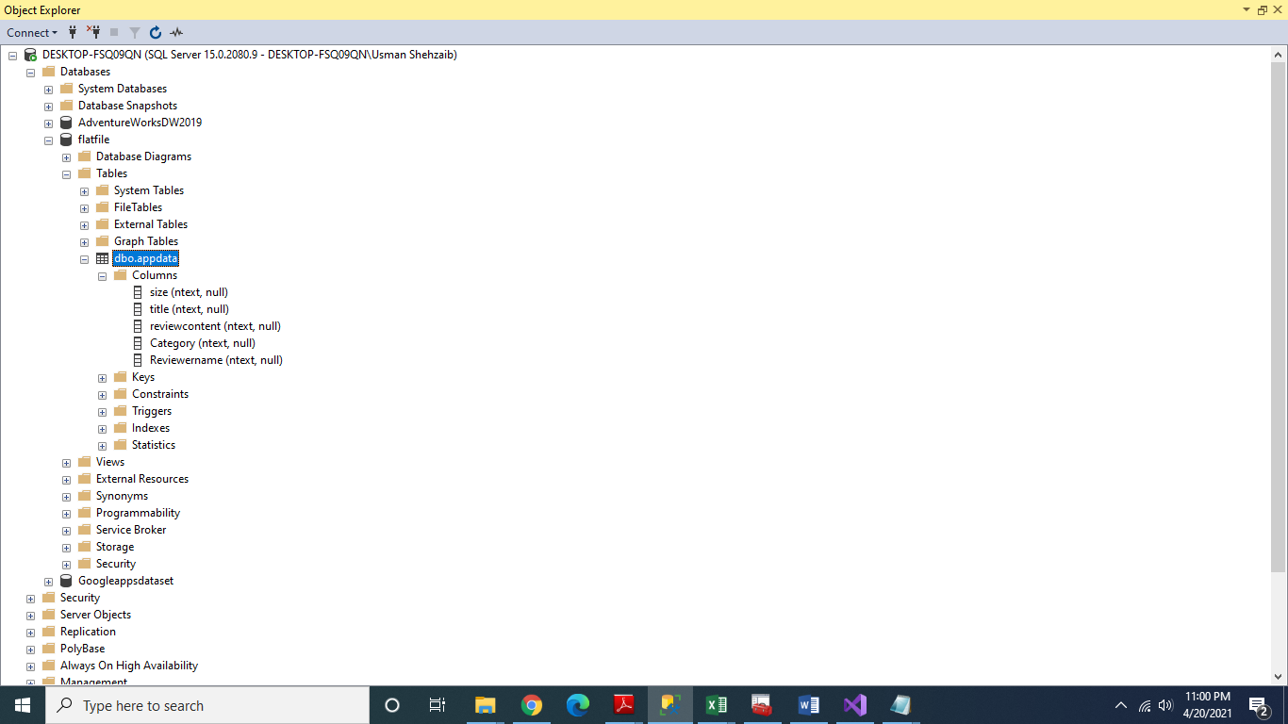

1. Now go to SSIS in Visual Studio and double click OLE DB destination and configure it as shown

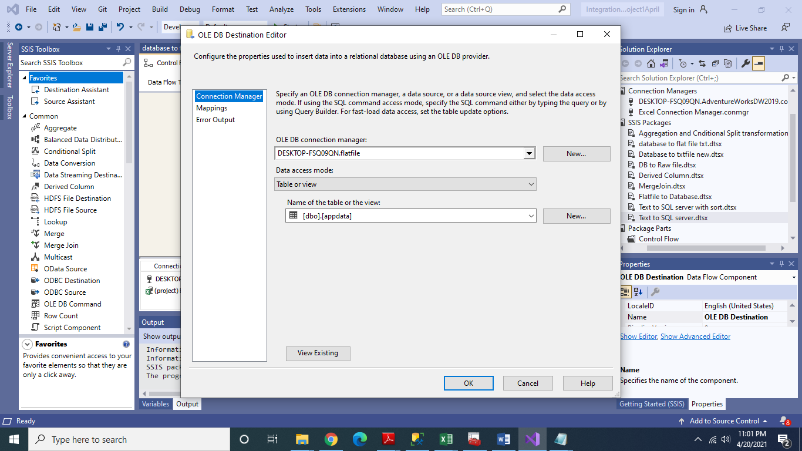

1. Now perform mappings of columns as shown

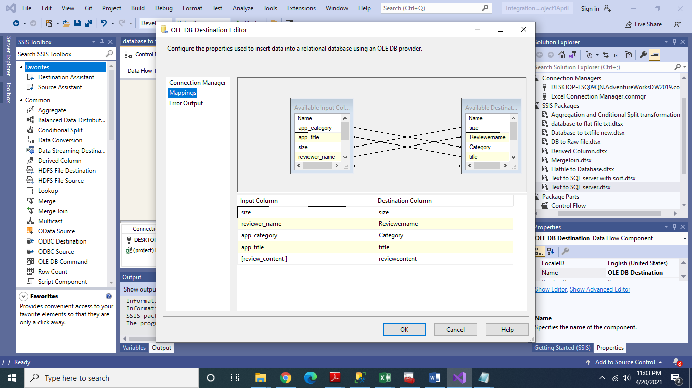

1. Execute the package on successful completion data will be loaded into appdata table in flatfile database.